`

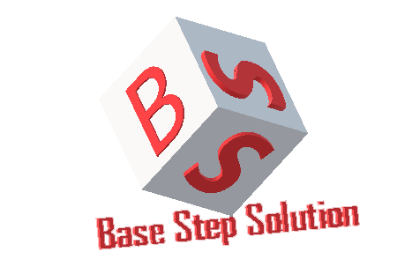

Meeting Minutes

Van Lang Admissions

# Revision Table

|  |  |  |  |
| --- | --- | --- | --- |
| Author | Date | Reason for changes | Version |
| Khoi Nguyen | 24/10/2016 | Initial Document | 1.0 |

Table of Contents

Revision Table 1

I. Purpose 3

II. Participant in meeting 3

III. Content of meeting 3

IV. To do task 4

|  |  |  |  |  |  |
| --- | --- | --- | --- | --- | --- |
| **Writer:** | Khởi Nguyễn | **Location:** | 7 Floor of Van Lang university | | |
| **Date:** | 24/10/2016 | **Start:** | 10h50 | **Finish:** | 12h |

# Purpose

* Review Process
* Discuss about requirement phase , how to get requirement of customer

# participant in meeting

Mentor Lê Sĩ Phú

Nhóm Capston:

* Nguyễn Thái Hiền
* Nguyễn Hoàng Anh Tài
* Đoàn Anh Minh
* Trần Xuân Hải
* Nguyễn Anh Khởi
* Nguyễn Xuân Thái Hiền

# Content of meeting

- Review incremental process

+ Prototype -> Concept

+ Output of Architeture , what step after Architeture?

+ Where are release of Requirement phase?

+ Where is System test ?

+ Need to reseach and re-define process

- Discuss about requirement phase

+ Discuss about how to get requirement of customer

+ Need to get business goal , mission goal

+ Specially at vision , scope

+ Get clearly about contrains , business function

+ Get core value to limit scope

# To do task

* Update Project Plan
* Update Processes
* Prepare question to get requirement
* Learn software development ( NodeJS , MongoDB , AngularJS … )

---- *** ----